**ANGULAR 15**

**Angular Architecture**

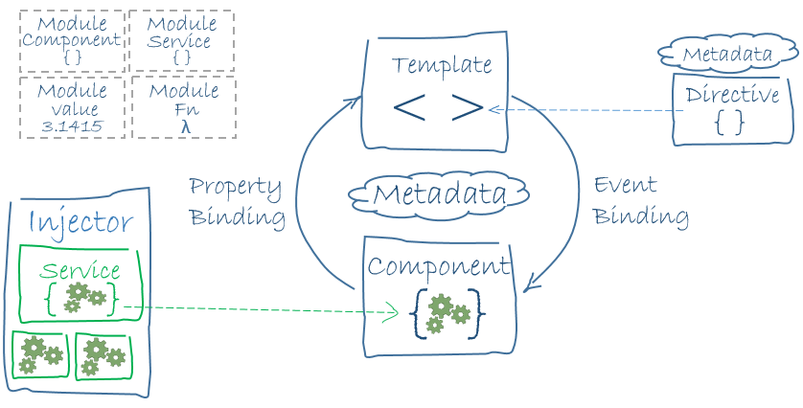

* SPA : Single Page Application
* AngularJS : Controller & Scaope
* TypeScript
* Dart, js, ecma script etc…

1. Node to be installed.
2. NPM : Node Package Manager – all the dependencies for the angular application.
3. Npm install -g @angular/cli
4. Ng new storeapp
5. Ng serve
6. To change the port number: ng serve - -port 4300

The angular.json file at the root level of an Angular workspace provides workspace-wide and project-specific configuration defaults.

These are used for build and development tools provided by the Angular CLI.

The presence of a tsconfig.json file in a directory indicates that the directory is the root of a TypeScript project.

The tsconfig.json file specifies the root files and the compiler options required to compile the project.

The package.json file contains the metadata information. It basically consist of the properties to identify the module/project such as the name of the project, current version of the module, license, author of the project, description about the project etc.

DATA BINDING:

* Communication
* Between Model and View
* Types of Binding
  + Interpolation – One {{}}
  + Property Binding – One []
  + Event Binding – One ()
  + Property + Event – Two [], ()
  + One Way binding - {{}}, [] , ()
  + Two way binding [()], ngModel

